Stress effecting Muscle Recovery Time Psychology of Stress
Loras College
Psychology of Stress

Emily Monahan

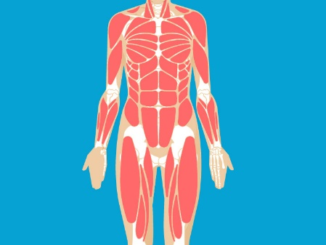
Introduction and Background
Stress causes bodily harm both psychically and psychologically. Physical stress can lead to poor immunity heath, that entails illness and injury proneness, pain in muscles, and a lack of overall energy. Stress causes a numerous of physiological responses: increased heartbeat, spiked blood pressure and glucose level, and digestive systems shut down. That is only if you are experiencing acute stress.
Chronic stress is extremely different. Protein and fat metabolism break down, immune cells breakdown, sodium and water are absorbed in the kidneys, blood volume and pressure are increased. Which from have chronic stress, just the protein and fat breakdown should be a clear understanding of why muscle recovery is so affected by stress. Your body cannot function properly, nor are you able to absorb nutrients properly and help your body recover after a good workout or just any exercise.
Muscles Fatigue is the “reduction in the ability of the muscles to produce force or power” and that this fatigue regularly begins once the activity, usually a workout or longer exercise is finished or sometimes before its over.
How muscles Recover and the Effect of Stress:
Despite whether your stress is chronic or acute, your progress can regress, which is a direct correlation to a lack of proper muscle recovery. When your muscles recovery properly they ‘grow,’ you are allowing your body to develop properly to be able to have greater muscle gain. When you are stress out your body is focused on the bigger issues on hand. It is making sure you are staying alive before worrying about how much your muscles are growing. For example, a study done on students shows, “The students were then asked to do heavy resistance exercise—six sets of 10 reps on a legs press machine at 80-100% of their 10-rep max. The result: The students who signaled high stress more slowly recovered their muscle function.” Some researchers suggest that cutting volume and intensity of a workout can help cut recovery time because you are not straining your muscles as much, but others say you should just take a few days at a time to properly allow your muscles to recovery if you are experiencing chronic stress.
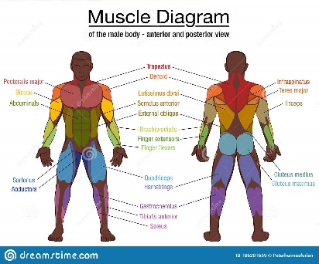
References
Stress Can Sabotage Your Muscle Gains and Workout Recovery. Here’s How to Deal With It. (mensjournal.com)
Resistance Training Load Effects on Muscle Hypertrophy and Strength Gain: Systematic Review and Network Meta-analysis (loras.edu)
Benjamin K. Barry, and Roger M. Enoka. “The Neurobiology of Muscle Fatigue: 15 Years Later.” Integrative and Comparative Biology, vol. 47, no. 4, Oxford University Press, 2007, pp. 465–73, http://www.jstor.org/stable/4540179.
Anderson Souza Oliveira & Mauro Gonçalves (2008) Neuromuscular Recovery of the Biceps Brachii Muscle After Resistance Exercise, Research in Sports Medicine, 16:4, 244-256, DOI: 10.1080/15438620802310800
Stress Shown to Impair Recovery From Workouts - Breaking Muscle

